AML TRANSACTION & FRAUD ANALYSIS DASHBOARD
USING MICROSOFT POWER BI
PROJECT REPORT
Submitted By
Name : DHARSHINI
Tool Used : Microsoft Power BI Desktop

Introduction
For this project, I created an interactive AML Transaction & Fraud Analysis Dashboard using Microsoft Power BI Desktop. The main aim of this project was to analyse financial transactions and understand how data can be used to identify and monitor fraudulent activities.
AML stands for Anti-Money Laundering. It refers to the process of identifying and preventing illegal financial activities, including money laundering and suspicious transactions. Financial institutions handle a large number of transactions every day, so analysing all the transactions manually can be difficult. Data analysis and visualisation tools can help in understanding transaction patterns and identifying activities that may require further investigation.
The dataset used for this project contains information about financial transactions, transaction amounts, timestamps, account details, fraud status, and alert types. Using these details, I analysed the overall transaction activities and examined the distribution of fraudulent and non-fraudulent transactions.
First, I imported the dataset into Power BI and checked the available columns. After preparing the data, I created different KPI cards, charts, and slicers to present the information in a simple visual format.
The dashboard includes total transaction amount, total number of transactions, total accounts, and fraudulent transactions. It also contains charts showing transaction volume over time, fraudulent transaction volume, transaction value based on fraud status, and the number of alerts under different alert types such as Cycle and Fan_in.
I also added interactive slicers for fraud status and alert type so that users can filter the dashboard and analyse specific transaction categories.
Through this project, I wanted to understand how Power BI can be used to analyse financial data and how data visualisation helps in identifying transaction patterns and understanding possible fraudulent activities.

Objectives
The main objectives of developing this dashboard were:
- To understand the basic concept of Anti-Money Laundering and financial fraud analysis.
- To analyse the overall financial transaction activities using the available dataset.
- To calculate and display important indicators such as total transaction amount, total transactions, total accounts, and fraudulent transactions.
- To understand how transaction volume changes across different timestamps.
- To analyse the number of fraudulent transactions over time.
- To compare the total transaction value of fraudulent and non-fraudulent transactions.
- To understand the distribution of transactions based on their fraud status.
- To analyse different types of fraud alerts, such as Cycle and Fan_in.
- To identify transaction patterns that may require further attention and investigation.
- To create interactive slicers that allow users to explore the data based on different conditions.
- To improve my practical knowledge of Microsoft Power BI, data visualisation, and financial data analysis.
- To understand how dashboards can help present large amounts of data in a simple and meaningful way.

Dataset Description
For this project, I used an AML Transaction and Fraud Analysis dataset containing information about financial transactions and fraud-related activities.
The dataset consists of different fields that help in analysing transaction details, account information, fraud classifications, and alert categories.
The major fields used in the dashboard include:
FIELD | DESCRIPTION
TIMESTAMP | Represents the time or sequence associated with a transaction.
TRANSACTION AMOUNT | Indicates the monetary value involved in a financial transaction.
TRANSACTION ID | Unique identification number assigned to a transaction.
ACCOUNT ID | Unique identification number associated with a financial account.
IS_FRAUD | Indicates whether a transaction is classified as fraudulent or non-fraudulent.
ALERT_ID | Unique identification number assigned to a fraud alert.
ALERT_TYPE | Represents the category of alert generated for a particular transaction pattern.
The dataset contains two major alert types displayed in the dashboard:
1. Cycle
Cycle refers to a transaction pattern in which money moves between different accounts in a circular manner and may eventually return to the original account or an account connected to it.
For example, money may be transferred from Account A to Account B, then from Account B to Account C, and finally back to Account A. Such patterns may require further examination because they can be used to hide the original movement of funds.
2. Fan_in
Fan_in refers to a transaction pattern in which money is received from multiple accounts into a single account.
For example, several different accounts may transfer money into one particular account. This type of pattern can be examined to understand the source of funds and identify potentially unusual transaction activities.
These fields provide useful information for analysing financial transactions and understanding different patterns that may be associated with suspicious activities.
4. Data Preparation
Before creating the dashboard, I prepared the dataset using Microsoft Power BI Desktop.
Data preparation is an important step because the quality and structure of the data affect the accuracy of the analysis and visualisations.
The following steps were carried out:
- First, I opened Microsoft Power BI Desktop and imported the AML transaction dataset.
- After importing the dataset, I checked the available columns and understood the information provided in each field.
- I examined the data types of the columns to ensure that numerical fields and text fields were identified correctly.
- I checked the Transaction Amount field to ensure that it could be used for calculating the total transaction value.
- I examined the Timestamp field for analysing transaction volume over different time periods.
- I checked the Account ID field for understanding the number of accounts represented in the dataset.
- I examined the IS_FRAUD column, which contains True and False values, to distinguish fraudulent and non-fraudulent transactions.
- I checked the ALERT_ID and ALERT_TYPE columns to understand the different fraud alerts recorded in the dataset.
- I ensured that the required fields were suitable for creating KPI cards, charts, and slicers.
- Finally, I created the required measures and arranged the visualisations to develop the dashboard.
After completing these steps, I started creating the dashboard using different visualisation options available in Power BI.

5. DAX Measures Used
DAX stands for Data Analysis Expressions. It is a formula language used in Power BI to perform calculations and create measures from the available dataset.
In this project, I used measures to calculate important transaction-related values and display them through KPI cards and charts.
The major measures used in the dashboard include:
- Total Transaction Amount
This measure calculates the total monetary value of all transactions available in the dataset.
Purpose:
The purpose of this measure is to understand the overall amount of money involved in the recorded financial transactions. It gives a quick idea about the total transaction value handled by the system.
- Total Transactions
This measure calculates the total number of transactions recorded in the dataset.
Purpose:
It helps understand the overall volume of financial activities. It also provides information about how many transactions are available for analysis.
- Total Accounts
This measure calculates the total number of accounts represented in the dataset.
Purpose:
It helps identify the number of accounts involved in the transaction activities. This information is useful for understanding the scale of the transaction network.
- Fraudulent Transactions
This measure calculates the number of transactions classified as fraudulent using the IS_FRAUD field.
Purpose:
It helps identify how many transactions are marked as fraudulent in the dataset. This measure is useful for understanding the number of transactions that may require additional examination.

- Transaction Volume Across Timestamp
This calculation is used to analyse the number of transactions across different timestamps.
Purpose:
It helps understand how transaction activities change over time. By using a line chart, I can observe increases, decreases, and variations in the number of transactions.
- Fraudulent Transaction Volume
This calculation focuses on the volume of transactions classified as fraudulent across different timestamps.
Purpose:
It helps analyse how fraudulent transaction activities change over time. It also makes it easier to observe periods where fraud-related activities are relatively higher or lower.
These measures helped me present the important information in a simple format and made the dashboard easier to understand.

Dashboard Components
The dashboard was created using different visualisation elements available in Microsoft Power BI. Each visual provides a different view of the transaction and fraud-related information.
- KPI Cards
The top section of the dashboard contains four KPI cards that display the major transaction indicators.
The cards display the following values:
KPI | VALUE
Total Transaction Amount | $153.479506205bn
Total Transactions | 1M
Total Accounts | 10K
Fraudulent Transactions | 2K
These KPI cards provide a quick summary of the dataset without requiring users to examine every individual chart.
The Total Transaction Amount shows the overall financial value of the recorded transactions. Total Transactions represents the number of transactions available in the dataset.
Total Accounts provides information about the number of accounts involved, while Fraudulent Transactions displays the number of transactions classified as fraudulent.
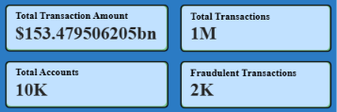
I used KPI cards because they make the important figures clearly visible at the top of the dashboard and help users understand the overall transaction activities quickly.

- Transaction Volume Across Timestamp
A line chart is used to display the transaction volume across different timestamps.
The horizontal axis represents the timestamp, while the vertical axis represents the total number of transactions.
The chart shows how transaction activities change across the recorded timestamps. It contains variations in transaction volume, with some periods showing higher activity and other periods showing comparatively lower activity.
By using this chart, I can understand the general transaction pattern and observe changes in transaction activities over time.
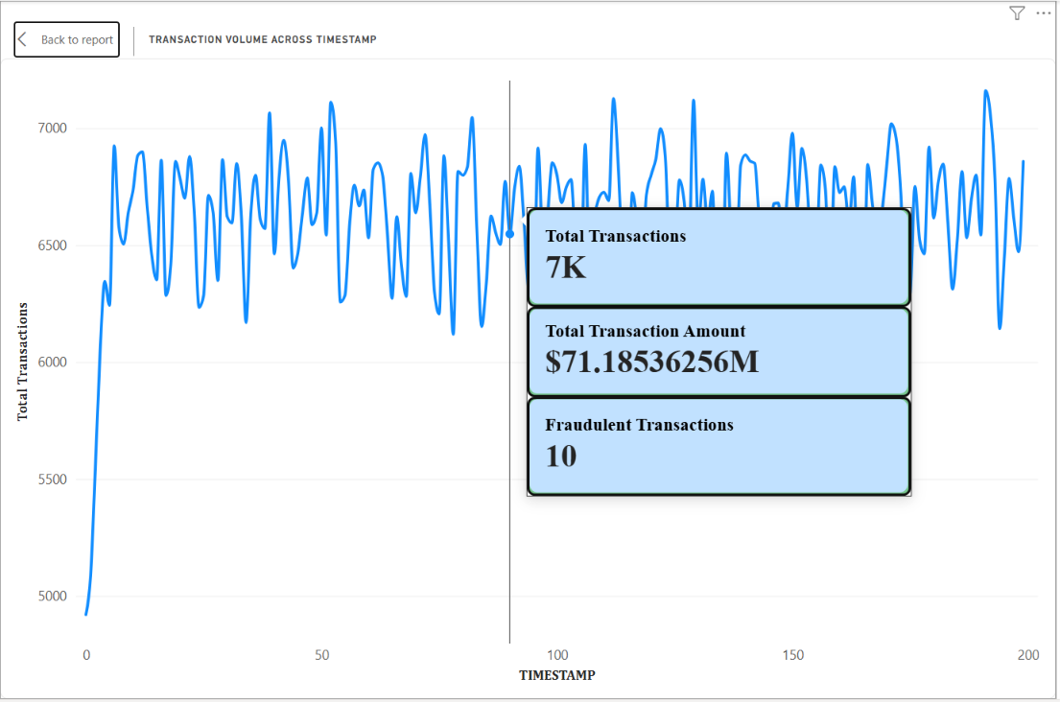
This visual is useful because monitoring transaction volume can help identify unusual increases or decreases that may require further examination.
- Fraudulent Transaction Volume Across Timestamp
Another line chart is included to analyse fraudulent transaction volume across different timestamps.
Unlike the previous chart, which represents the overall transaction volume, this chart focuses only on transactions classified as fraudulent.
The chart displays variations in fraudulent transaction activities over time. It helps understand whether the number of fraudulent transactions remains relatively stable or changes during different periods.
For example, if there is a sudden increase in fraudulent transaction volume during a particular period, it may indicate a pattern that needs additional investigation.
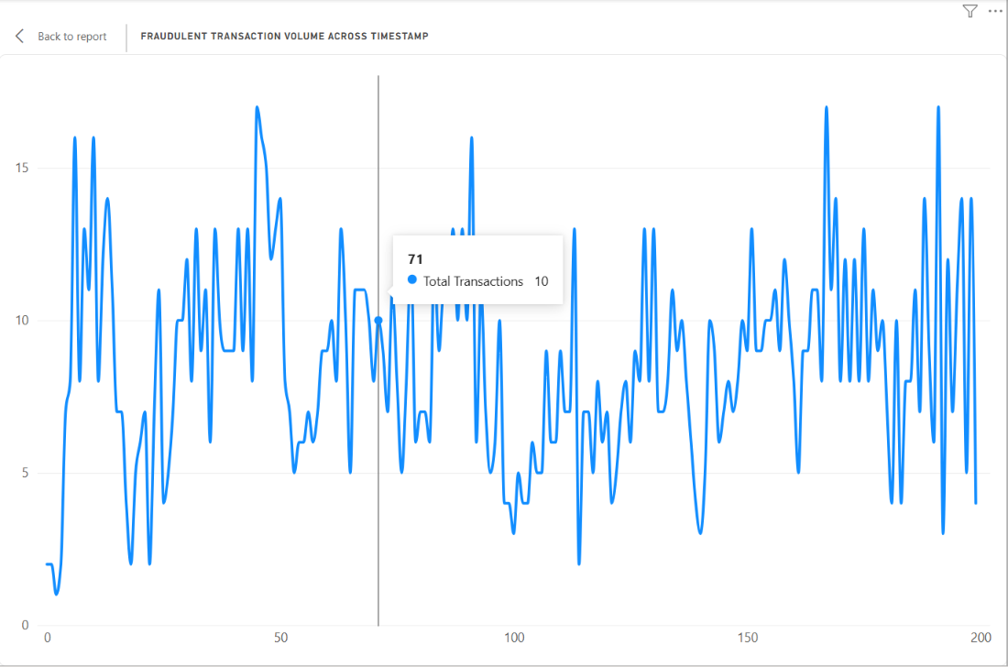
I included this chart to make it easier to compare fraud-related activity across timestamps and understand how fraudulent transactions are distributed over time.

- Total Transaction Value by Fraud Status
A column chart is used to compare the total transaction amount based on fraud status.
The chart contains two categories:
  - False: Represents transactions classified as non-fraudulent.
  - True: Represents transactions classified as fraudulent.
The horizontal axis represents the fraud classification, while the vertical axis represents the total transaction amount.
This chart helps compare the financial value of fraudulent and non-fraudulent transactions.
From the dashboard, it can be observed that the transaction value associated with the False category is considerably higher than the True category.
This visual is useful because it provides an understanding of how the total transaction amount is distributed between the two classifications.
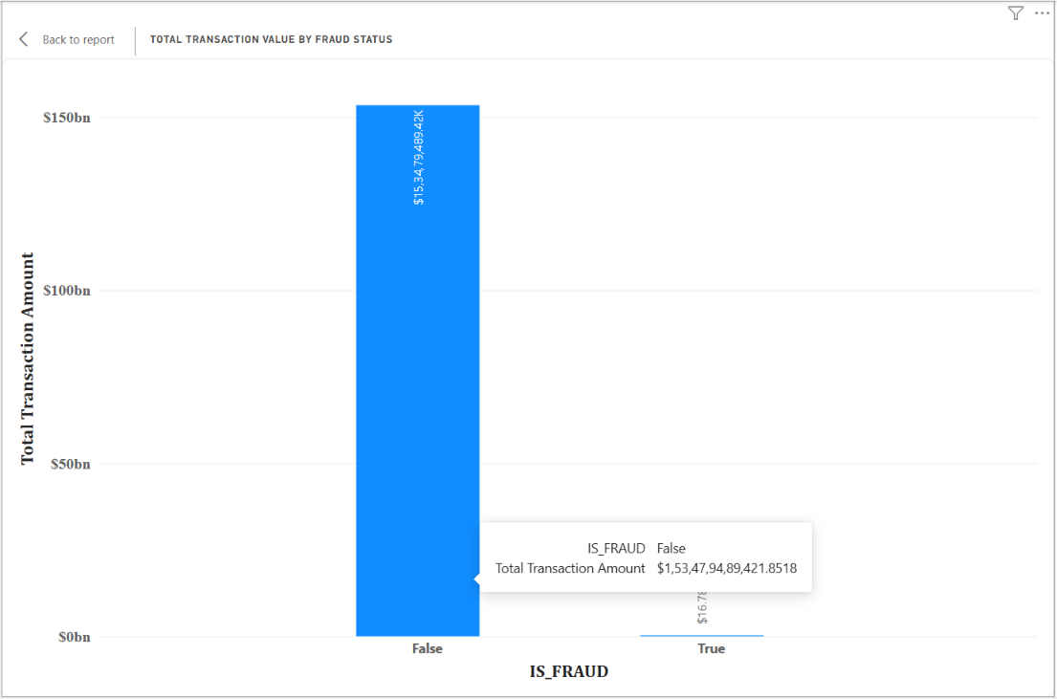
It also helps users focus on the financial value associated with transactions marked as fraudulent.

- Count of ALERT_ID by ALERT_TYPE
A horizontal bar chart is used to display the number of alerts based on their alert types.
The chart contains two alert categories:
  - Cycle
  - Fan_in
The horizontal axis represents the count of ALERT_ID, while the vertical axis represents the alert type.
The chart shows that both alert categories have a considerable number of recorded alerts. Cycle has a higher alert count than Fan_in in the displayed dashboard.
This visual helps compare the frequency of different alert types and understand which transaction patterns are more commonly identified in the dataset.
For example, Cycle alerts can help identify circular movement of money between accounts, while Fan_in alerts can help examine situations where multiple accounts transfer money into a single account.
I used a horizontal bar chart because it makes the comparison between the two alert categories easy to understand.

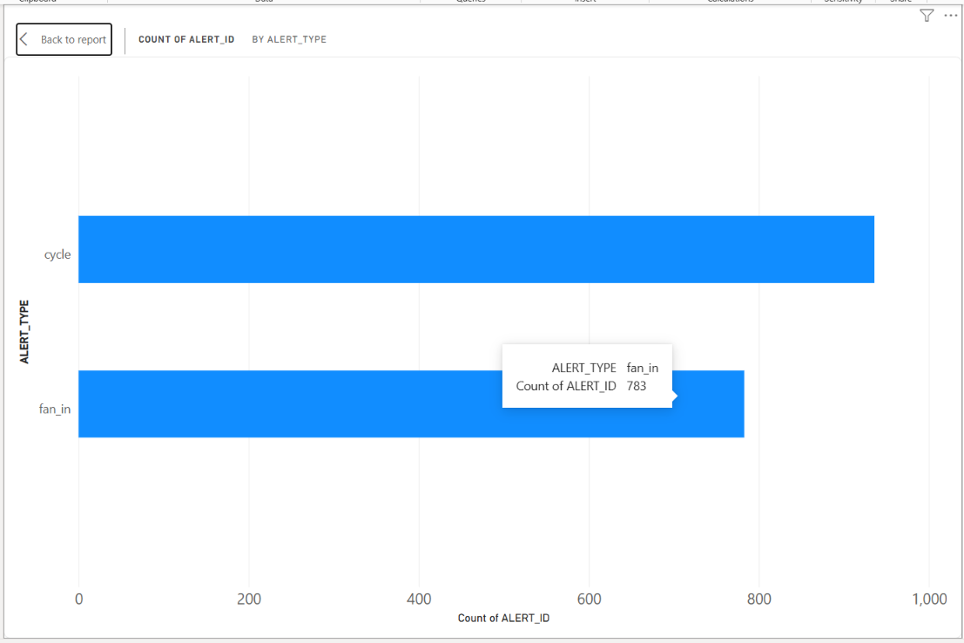
- Transaction Distribution by Fraud Status
A doughnut chart is used to display the distribution of transactions based on their fraud status.
The chart contains two categories:
  - False – Non-fraudulent transactions.
  - True – Fraudulent transactions.
The doughnut chart provides a visual representation of the proportion of transactions classified under each category.
From the dashboard, it can be observed that non-fraudulent transactions form the major portion of the total transaction volume, whereas fraudulent transactions represent a comparatively smaller portion.
This chart makes it easier to understand the overall distribution of transactions and compare the proportion of fraudulent and non-fraudulent activities.
I included this visual because it provides a simple way to understand the fraud distribution without examining individual transaction records.

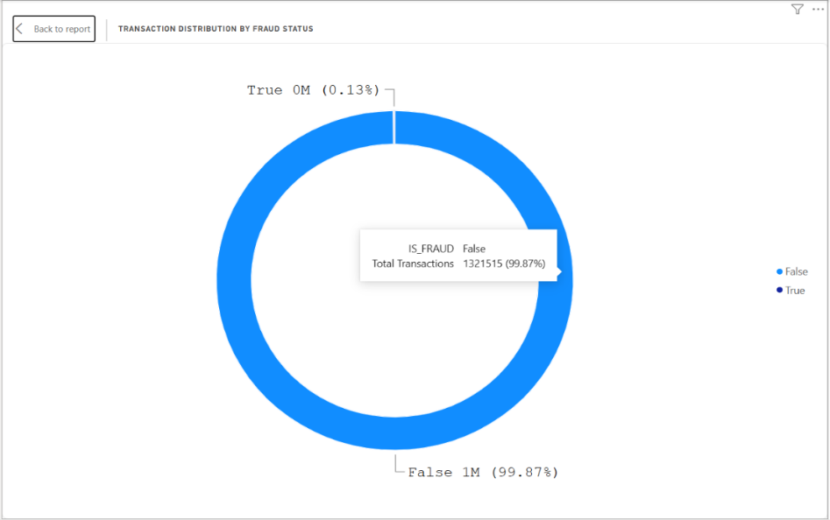

- IS_FRAUD Slicer
An interactive slicer named IS_FRAUD is included on the right side of the dashboard.
It contains two selection options:
  - False
  - True
The slicer allows users to filter the dashboard according to the fraud classification.
For example, when True is selected, users can focus on transactions classified as fraudulent. Similarly, selecting False allows users to analyse non-fraudulent transactions.
This feature is useful because it allows users to study the two categories separately and understand their differences.
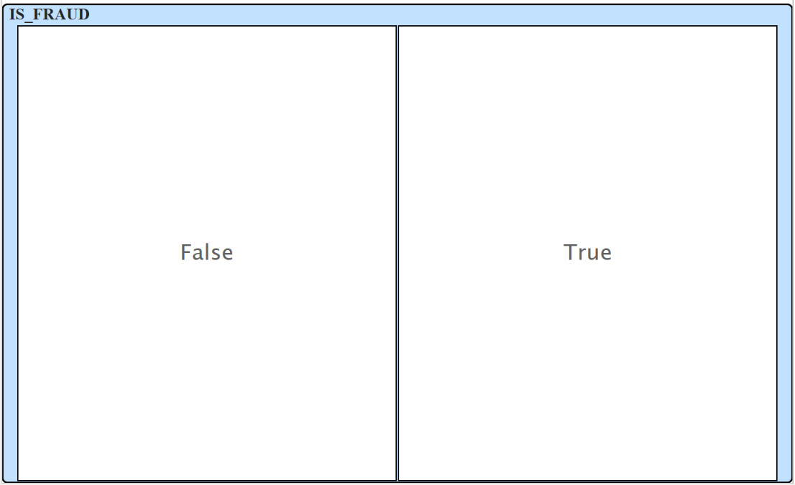

- ALERT_TYPE Slicer
Another slicer named ALERT_TYPE is included in the dashboard.
It contains two selection options:
  - Cycle
  - Fan_in
This slicer allows users to select a particular alert category and analyse the related information.
For example, selecting Cycle allows users to focus on cycle-related alerts, while selecting Fan_in helps analyse the alerts associated with funds received from multiple accounts.
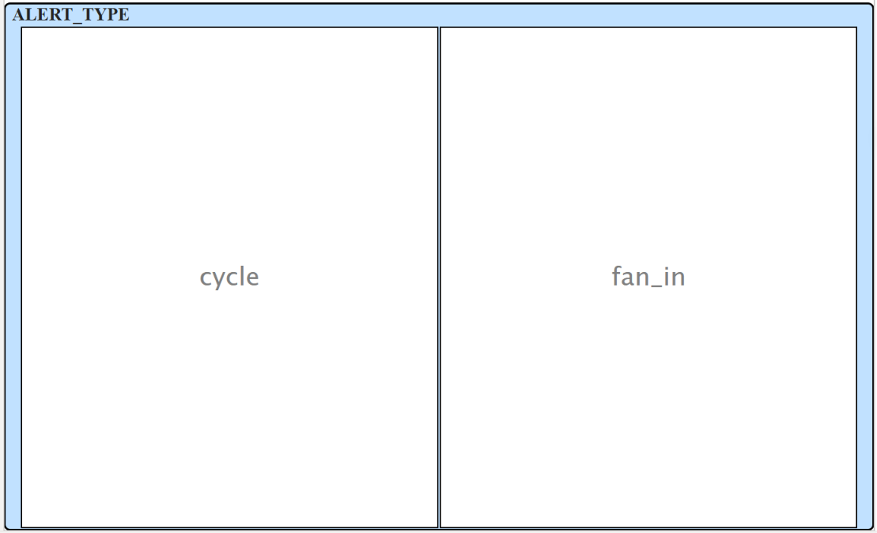
This makes the dashboard more interactive and helps users explore different types of transaction patterns.

Interactivity of the Dashboard
One of the important features of Microsoft Power BI is its ability to create interactive dashboards.
In this project, I added two slicers, IS_FRAUD and ALERT_TYPE, to allow users to filter the transaction data based on their requirements.
The slicers make it possible to explore the dataset without manually changing the charts or creating separate reports.
The following interactions are available:
- Selecting True in the IS_FRAUD slicer allows users to analyse fraudulent transactions.
- Selecting False allows users to focus on non-fraudulent transactions.
- Selecting Cycle in the ALERT_TYPE slicer helps analyse cycle-related alerts.
- Selecting Fan_in allows users to examine fan-in alert patterns.
- Users can change their selections to compare different transaction categories.
When a slicer selection is made, the connected visualisations update according to the filter and interaction settings configured in Power BI.
For example, selecting a particular fraud status can help users examine the corresponding transaction information through the available charts.
The interactive features make the dashboard more useful than a normal static report because users can explore the information from different perspectives.

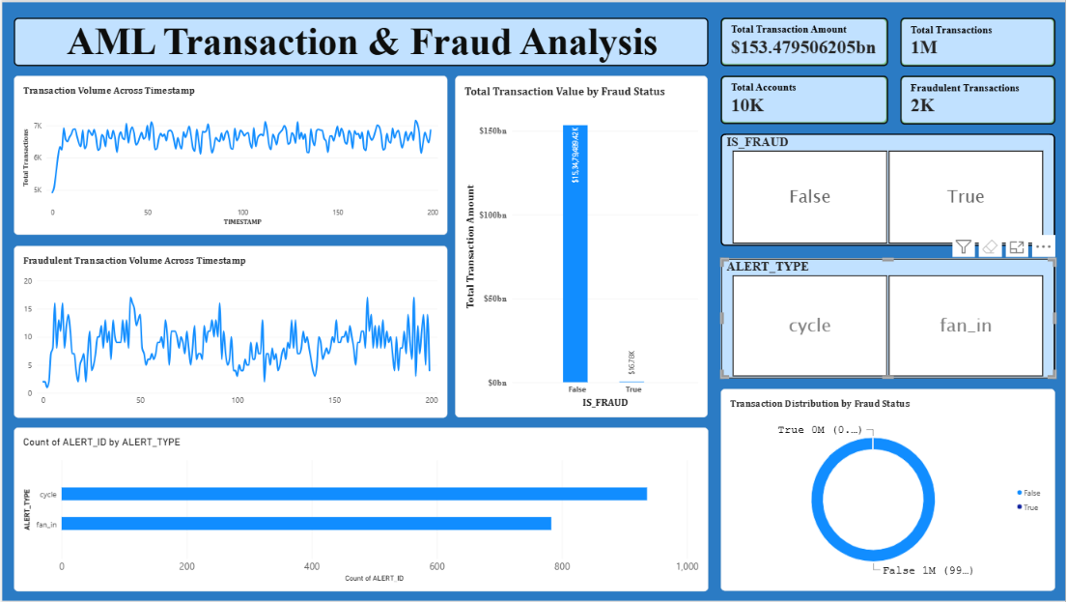

Key Findings
After creating and analysing the dashboard, I observed the following points:
- The dashboard displays a total transaction amount of approximately $153.48 billion.
- The total number of transactions is approximately 1 million.
- The dataset represents approximately 10,000 accounts.
- The dashboard displays approximately 2,000 fraudulent transactions.
- The transaction volume line chart shows variations in transaction activities across different timestamps.
- The fraudulent transaction volume chart helps observe changes in fraud-related activities over time.
- The transaction value chart shows a considerable difference between the False and True fraud classifications.
- Non-fraudulent transactions represent the major portion of the overall transaction distribution.
- Fraudulent transactions form a comparatively smaller portion of the total transaction volume.
- The alert analysis includes two major categories, Cycle and Fan_in.
- Cycle alerts have a higher count than Fan_in alerts in the displayed dashboard.
- The bar chart makes it easier to compare the number of alerts under different categories.
- The IS_FRAUD slicer allows users to examine fraudulent and non-fraudulent transactions separately.
- The ALERT_TYPE slicer helps users focus on specific alert categories.
- The combination of KPI cards, line charts, a column chart, a horizontal bar chart, and a doughnut chart provides a clear understanding of the transaction data.
Through these observations, I understood how different visualisations can be used together to analyse financial transactions and identify patterns that may need further attention.

Learning Outcomes
While completing this project, I gained practical knowledge of Microsoft Power BI and understood how it can be used for analysing financial transaction data.
The major things I learned through this project are:
1. Data Importing and Preparation
I learned how to import a dataset into Power BI, examine the available columns, check data types, and prepare the data for analysis.
2. Working with DAX Measures
I understood how DAX measures are used to calculate important values such as total transaction amount, total transactions, total accounts, and fraudulent transactions.
3. Creating Different Visualisations
I gained experience in creating KPI cards, line charts, column charts, horizontal bar charts, and doughnut charts based on the requirements of the analysis.
4. Using Interactive Slicers
I learned how slicers can be used to filter data and explore different categories without creating separate dashboards.
5. Understanding Financial Fraud Patterns
I gained a basic understanding of fraud classifications and alert types such as Cycle and Fan_in. I also understood how transaction patterns can be examined to identify activities that may require further investigation.
6. Dashboard Design
I learned how to arrange different visualisations, use suitable chart types, and organise important information to make a dashboard clear and understandable.
7. Data-Based Analysis
Most importantly, I understood how raw financial data can be converted into meaningful information through analysis and visualisation.

Conclusion
This project helped me understand how Microsoft Power BI can be used to analyse financial transactions and present fraud-related information through an interactive dashboard.
Using the AML Transaction and Fraud Analysis dataset, I created a dashboard containing KPI cards, transaction volume trends, fraudulent transaction analysis, transaction value by fraud status, alert type analysis, and transaction distribution by fraud status.
The KPI cards provide a quick overview of the total transaction amount, total transactions, total accounts, and fraudulent transactions. The line charts help analyse transaction activities over time, while the column chart and doughnut chart provide information about the distribution of transactions based on fraud status.
The horizontal bar chart helps compare different alert categories, such as Cycle and Fan_in. The slicers allow users to filter the information based on fraud status and alert type, making the dashboard more interactive.
Through this project, I also gained a basic understanding of Anti-Money Laundering activities and how transaction monitoring can help identify unusual financial patterns.
Overall, this project improved my practical knowledge of Power BI, DAX measures, data preparation, data visualisation, and interactive dashboard development. It also helped me understand the importance of data analysis in the financial sector, especially in areas related to transaction monitoring and fraud detection.
The project gave me an opportunity to apply the concepts of data analysis practically and understand how visual dashboards can make large amounts of financial information easier to interpret and analyse.

